**Accuracy Testing for UR5e robotic arm**

* **Objective**

**Determining the position and orientation of the robotic arm measured between UR5 system and physical system. Verification is done by considering two points in cartesian space between which the needle attached to the robot’s end-effector is set to move.**

* **Initial Setup**

Before carrying out testing, the robot has to be properly installed by a certified technician. Some steps are listed below to be strictly followed to avoid potential damage to the environment and the robot.

* 1. Ensure the robotic arm has ample space for movement.
  2. Ensure the docking is carried out in a proper way by the technician.
  3. Ensure the TCP calibration is done.
  4. The surface table shouldn’t be touched specifically when the testing is going on.
  5. Abstain going into robot’s vicinity when the testing takes place.
* **Surface alignment ( Plane alignment )**

Surface alignment requires the plane of the surface table (*Fig. 1*) to be aligned parallel to robot’s (*Fig. 2*) plane or perpendicular to the needle attached to the end-effector.

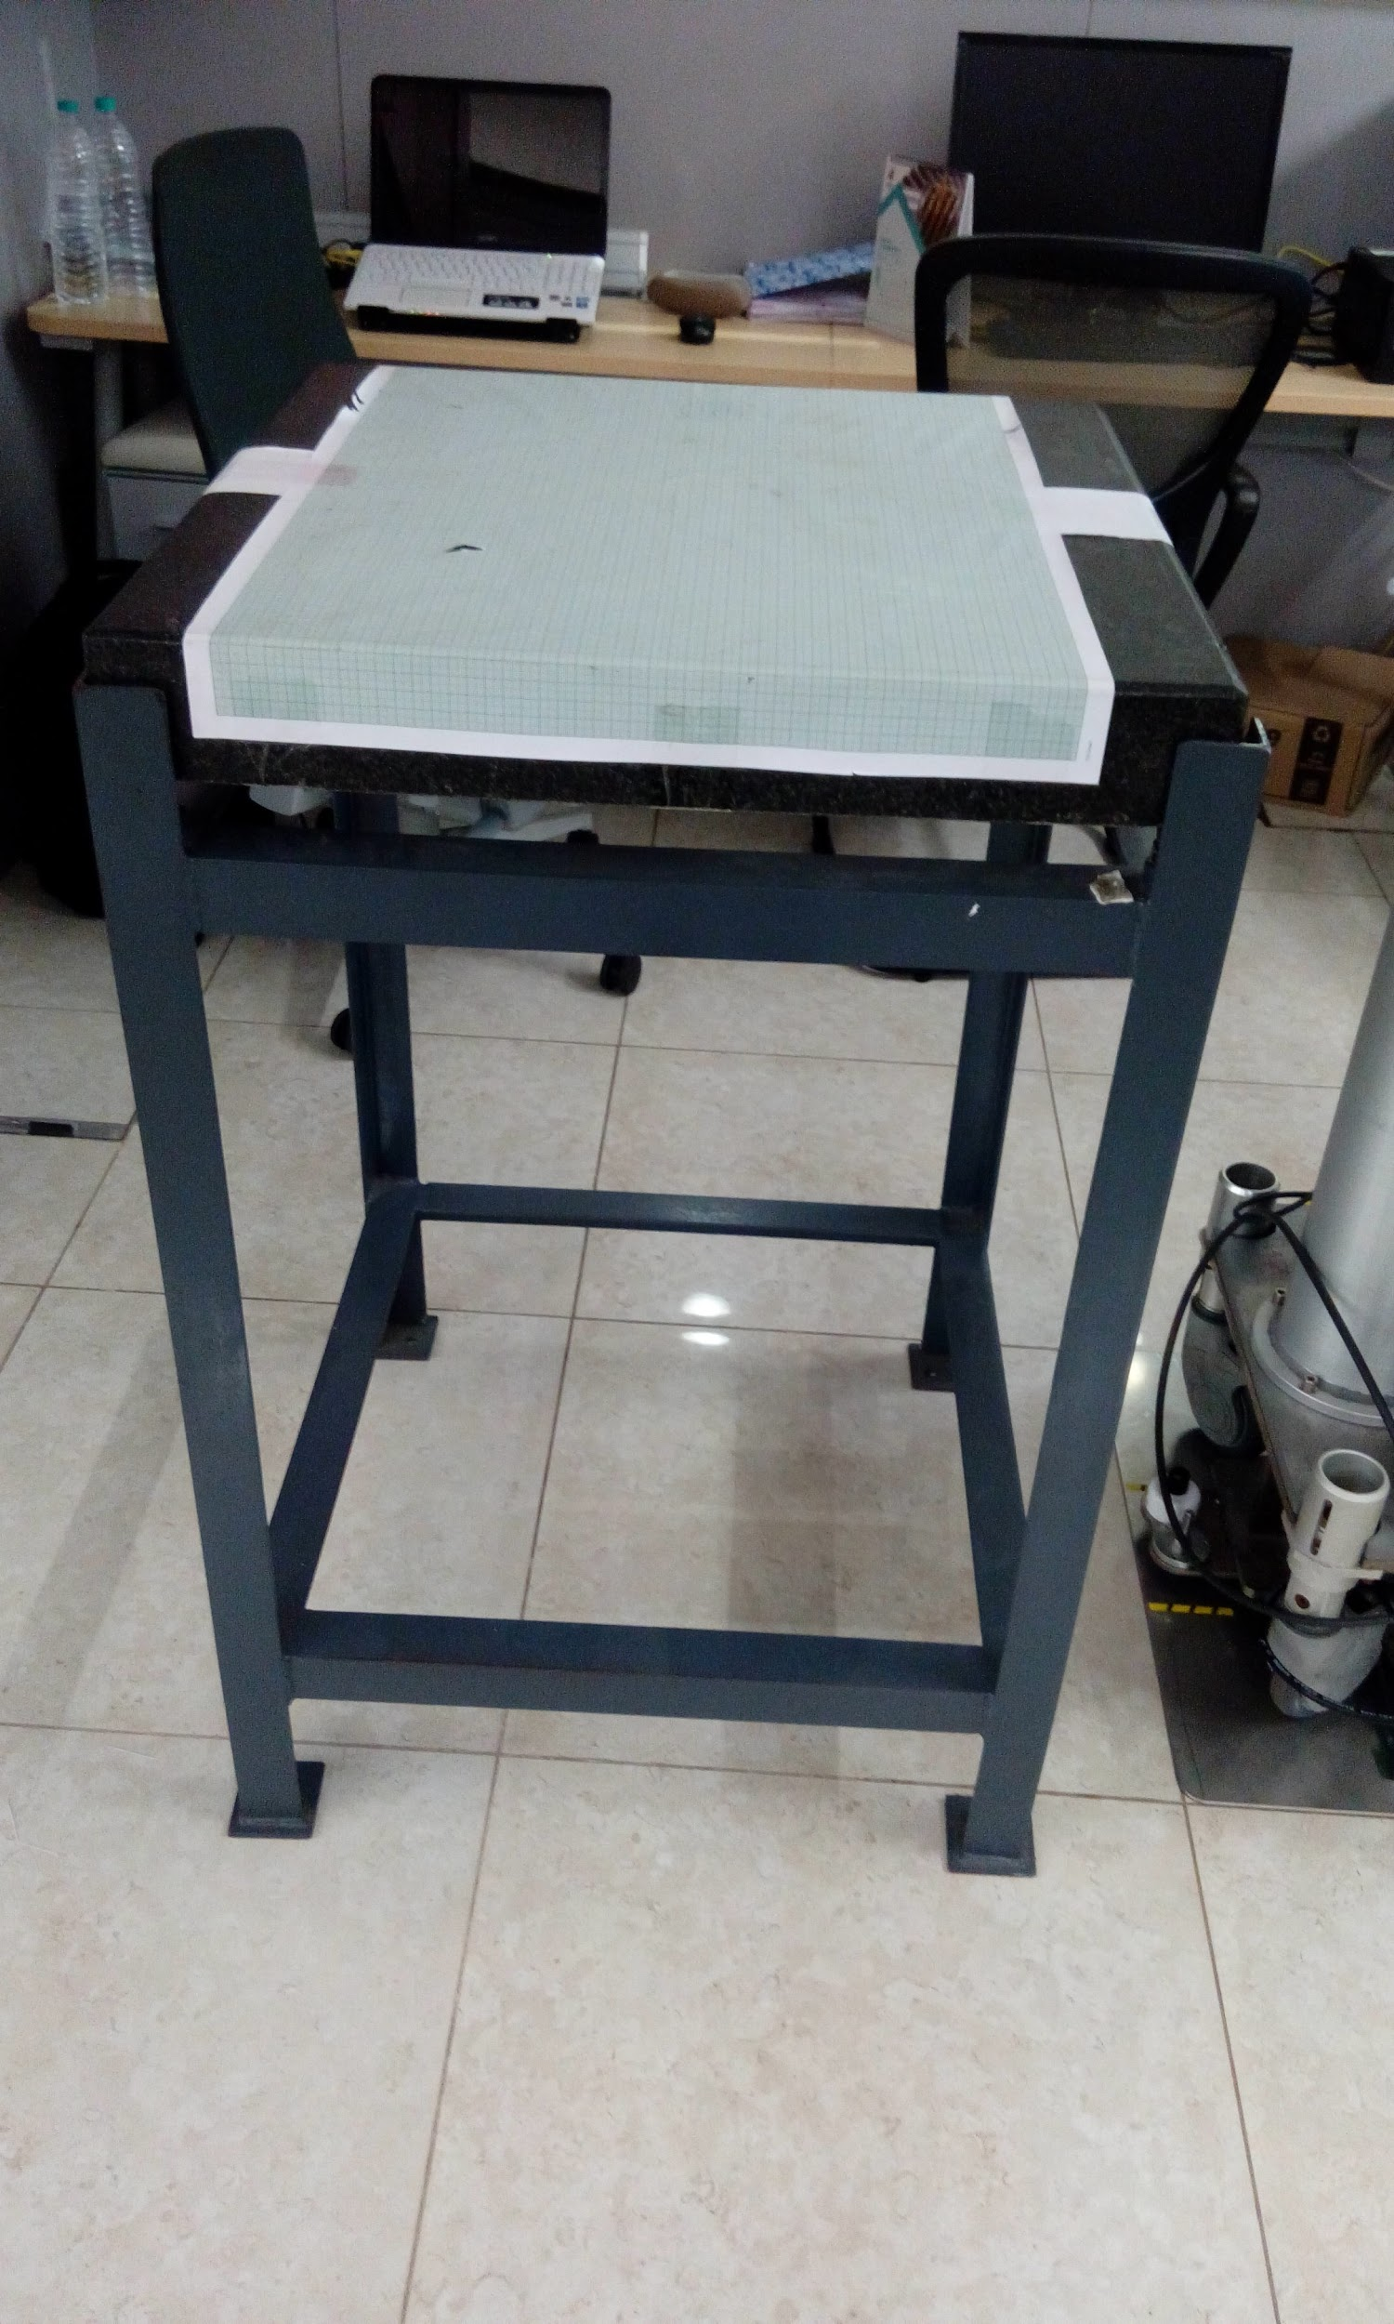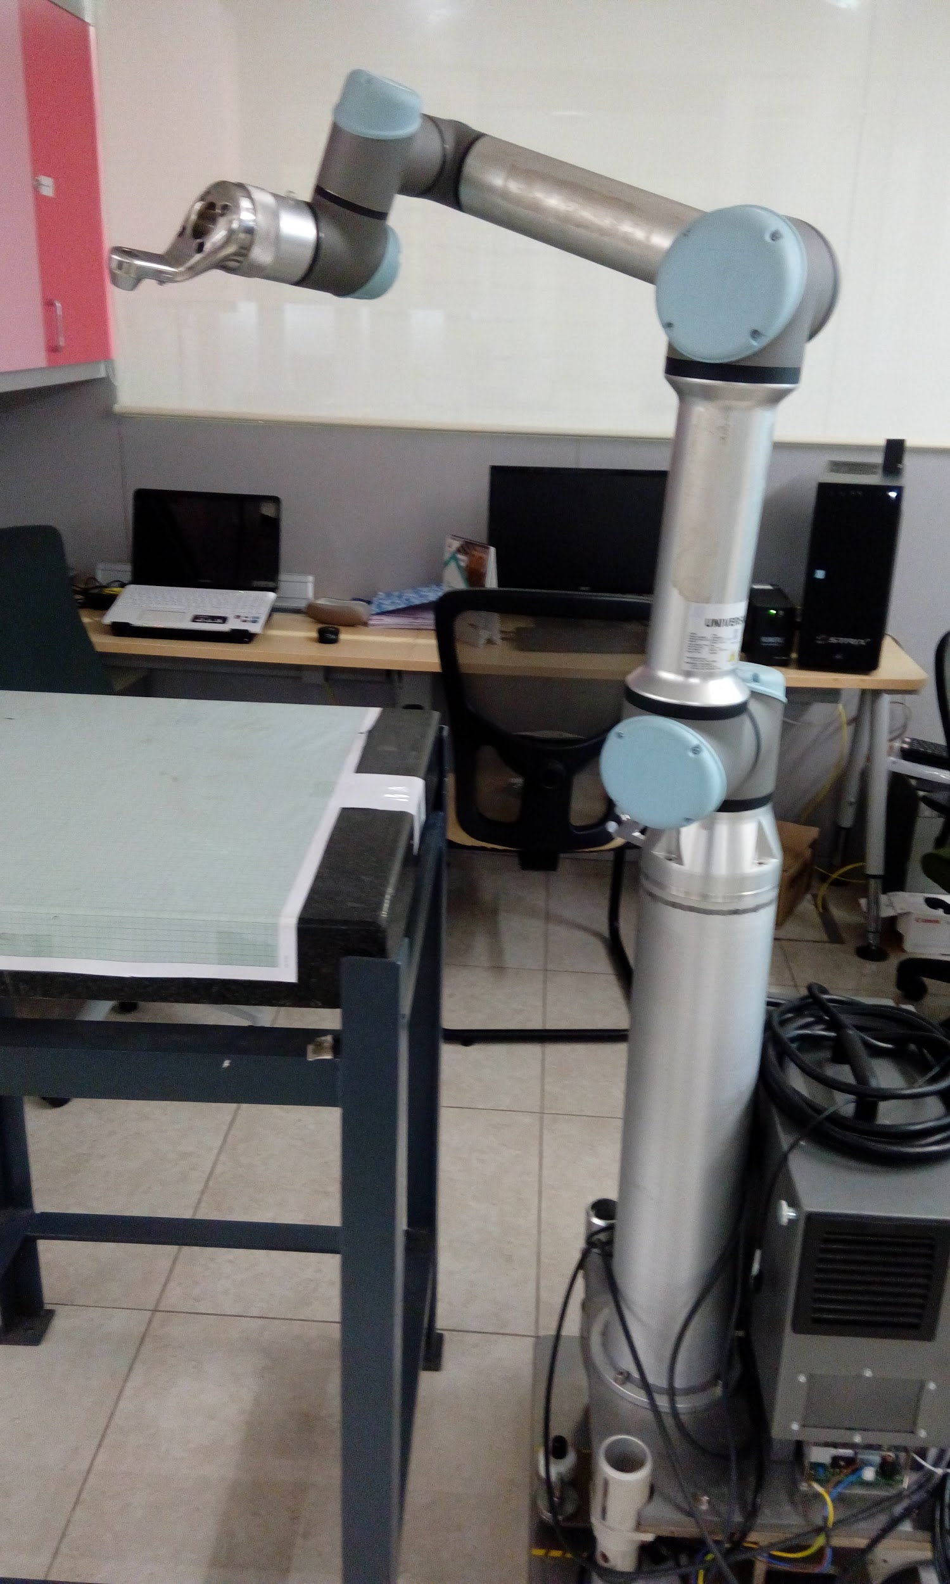

***Fig.1 Surface Table*** ***Fig.2 UR5 Robotic Arm***

* **TCP calibration (Tool Centre Point )**

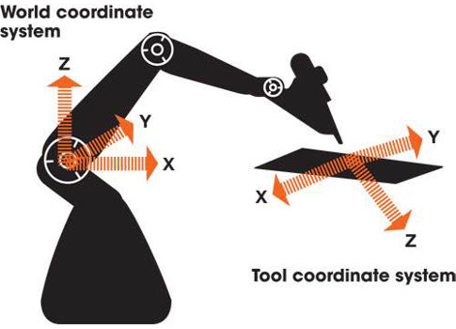

***Fig.3 coordinate system mapping***

Since the TCP point is shifted from robot to needle which is placed at the end effector, there is a need of calibration step to precisely locate its position and orientation. The protocol for this calibration is done by using UR5 system. 2 stage calibration is done (one for position and one for orientation) to avoid any system error.

* **Algorithm for testing protocol**

The initial step is to sample points from the plane which was made in line with the robot. The point is sampled by positioning the robot with the help of a needle using a graph sheet. Then using the position information a virtual sphere is constructed, which contains different entry points but same target point. This module is to create different angulation for robot position. Angle between entry points and target point is calculated before and after robot position to verify its accuracy. Since the whole system maintains the same target point, which is sampled from graph physical error can also be computed easily.

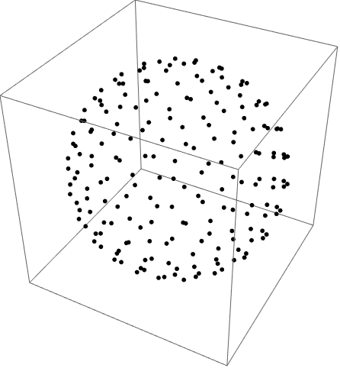

* **Procedure**

1. The surface alignment and TCP calibration is done initially in order to nullify any physical error from the system.
2. A point is sampled from graph sheet using a needle which is attached to the end effector of the robot.
3. Construction of virtual sphere, generating different target points.
4. Using constraint IK solutions, position the robot using a pair of points (Entry and Target) generated from sphere.
5. Measure the physical difference from the graph sheet (Negligible error - 0.5 mm)
6. Note down the UR5 system error of Entry, Target and Orientation before and after robot position. (Since all points are sampled from robot space, there is no need for registration)

* **Anomalies**
  1. We observed a bend in the needle with an error of 1mm, which created angulation error at times.
* **Calibrated setup**
  1. TCP point was calibrated with less than 0.2-0.3 mm error and same procedure was repeated
* **Results**
  1. All the results were tabulated and shared as a google sheet.

**Accuracy Testing for UR5e with REST Protocol**

The above setup was maintained for testing the REST protocol in which the data points are randomly sampled from the robot workspace. Those points were passed through a REST api upon which the robot position itself. The position accuracy was estimated between actual entry location and desired entry location. Nearly 110 points were sampled for this testing protocol and all the results were tabulated and shared as a google sheet.